National Park

|  |  |  |
| --- | --- | --- |
| **Supervisor.** | **Sir Hafiz Afzal Siddiqui** | |
| **Batch.** | **2310B2** | |
| **Group.** | **A** | |
| **Serial No.** | **Enrollment Number** | **Student Name** |
| 1. | Student1525898 | Fariz Ahmed |
| 2. | Student1523076 | Syed Muhammad Ali Azlan |
| 3. | Student1523718 | Abdul Wahab Irfan |
| 5. | Student1521147 | Zarrar Ahmed |
| 4. | Student1521141 | Zohaib Khan |

**ACKNOWLEDGEMENT**

Before anything, I would like to thanks my beloved Sir Hafiz Afzal Siddiqui who helped us a lot in reviewing this project within the limited time frame.

Secondly, we would also like to thank the eProject team at Aptech Head Office, who gave us the golden opportunity to do this wonderful project about Nexus Aquarium

Thirdly, we also thank the eProject team, some of the benefits are as under: Re-enforcement of skills happens in the experiential learning process. ∙ A mentor, ensuring that we do not get drifted, constantly guides us. ∙ It gives us a lot of confidence to face an interview as we have worked on a project. We can explain virtually everything on the subject we have le

***SYNOPSIS***

With the help of technology, we are providing people ease to book tickets and know our aquarium. We are providing relaxing survey to our website. Attached all the information about the main species of the ocean. So shares the perfect relaxing images through the website for everyone to know. For the convenience of the people we have provided map for the route. Best aquarium website to visit.

***PROBLEM DEFINITION***

Nexus Aquarium is located in city of Washington, which is the one of well-known place for tourism. Aquarium is very huge and comprises of marine life animals and they are fed and breeding. It is the big center for organizing the school events for the purpose of study and so on. For the children to visit an aquarium is big thing as they love to sea creatures. The organization wishes to make a website for the aquarium for which they have contacted you.

***CUSTOMER REQUIREMENT***

***SPECIFICATION (CRS)***

The Web site is to be created based on the following requirements.

1. The Home page must have well defined logo and image of the sea creatures.
2. Apart from home link, other links such as gallery section, certain information about animals (marine life animals) they have.
3. Contact details must be added.
4. Timing and location must be stated in the website
5. Events (separately for children) must be stated in the website with the proper schedule and details.
6. Online booking of event (Dummy page where information must be entered, and validation checking must be done)
7. Images of the aquarium location (site seeing must be included)
8. Navigation must be maintained smooth.
9. Color combination must be precise and uniformity must be maintained.
10. Categorization of the marine life animals and their different species information should be shown in tabular form.
11. Feedback form (dummy) should be provided.

***SCOPE OF THE WORK (IN BRIEF)***

The website is to be developed for the Windows Platform using HTML5, JavaScript and bootstrap jQuery. The site should work well in all leading browsers including Chrome, Firefox etc. Our welcome page icon is re-directed to the main web page Ever essential content direct to relative content.

***AGGREGATED SITEMAP***

***Screenshots***

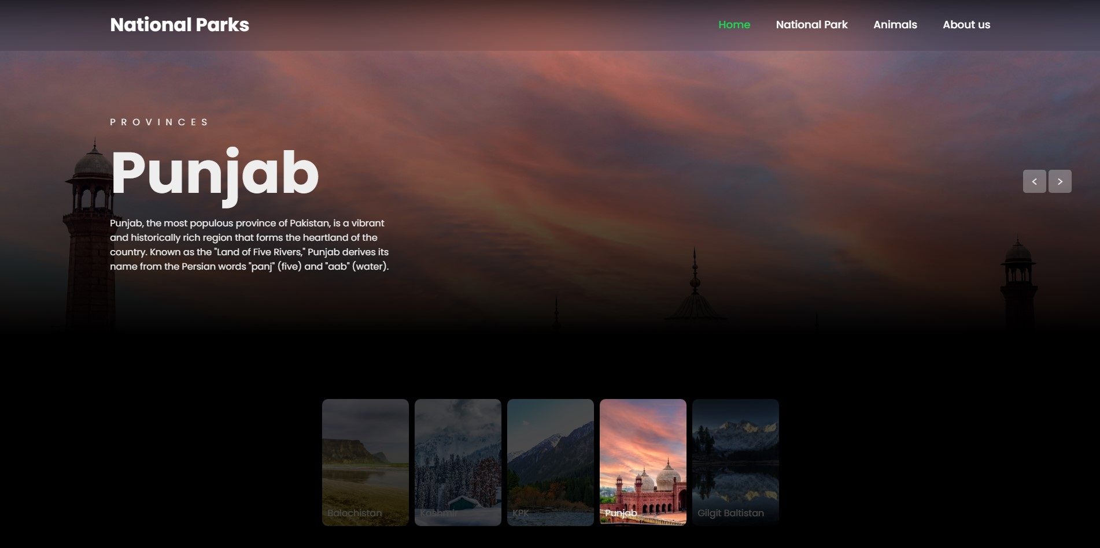



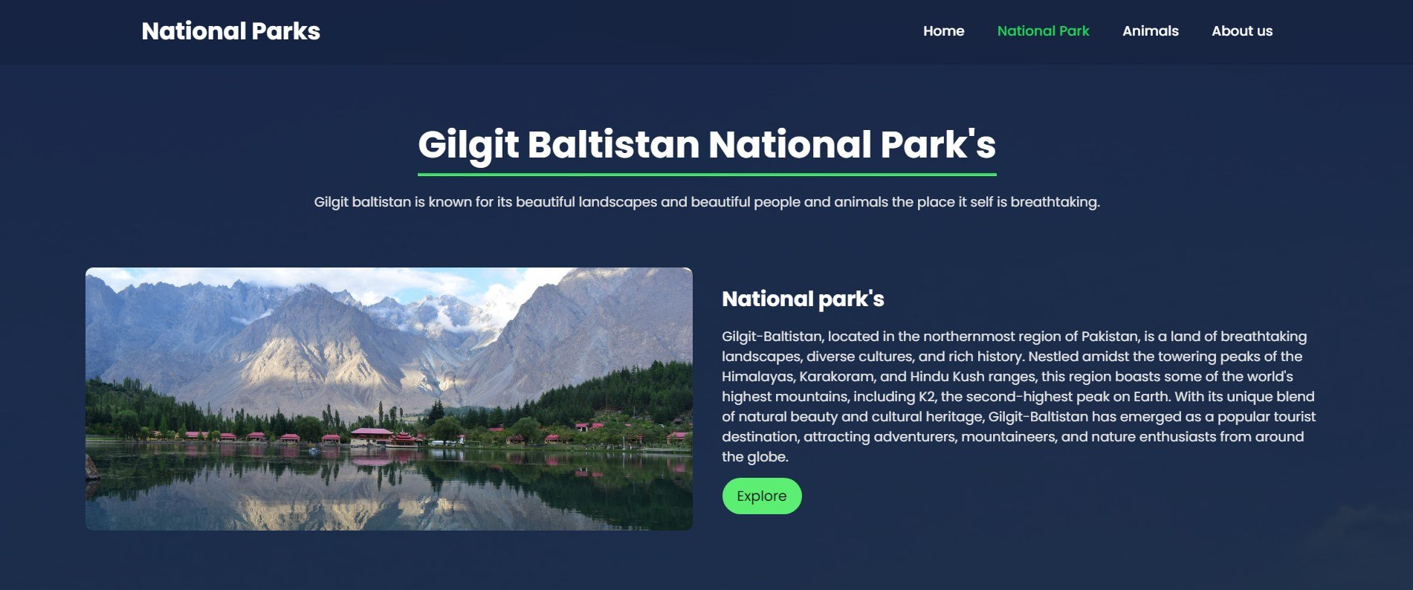

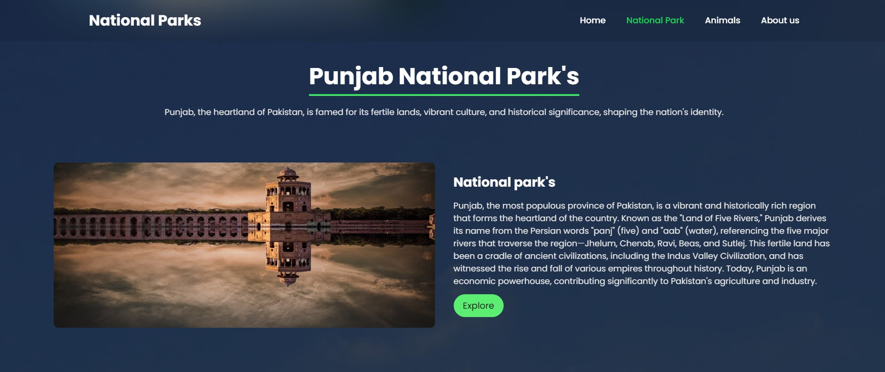

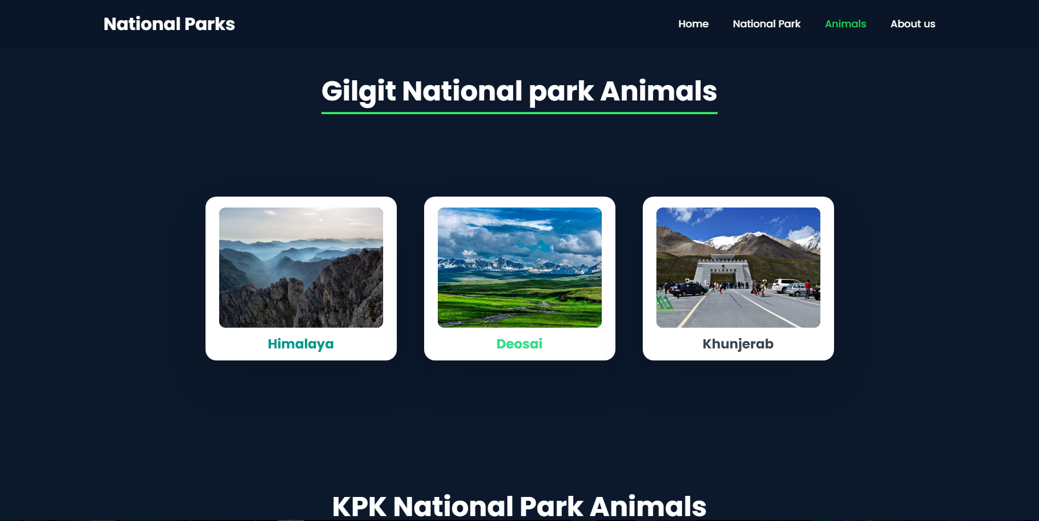

CONTENT



